|  |  |
| --- | --- |
| **Full name of student** | Muhammad Afzal Ismail |
| **Student ID number** | 170061238 |
| **Date of meeting (Time/Room)** | 19/02/19 12.15pm  G12 |
| **Date of previous meeting** | 07/02/19 |

**Meeting Agenda:**

|  |
| --- |
| 1. Discuss progress of the project. 2. Demonstrate the user interface that has been implemented up-to-date. 3. Discuss draft of Gantt chart and Rich picture. |

**Action Item/s from the previous meeting**

|  |
| --- |
| 1. To finalize the project outline, which will be reviewed again by the supervisor before submission. 2. To draft a Gantt chart to show how much time will be needed to complete each part of the project. This will be discussed during the next meeting. 3. Need to sketch and design the system/application for the project, showing the big picture of the system/application flow. 4. To work on storing file paths in a string array when a user chooses a file from the file browser. Storing the file paths as string will avoid high memory usage and computational complexity. The data will only be loaded when the user chooses to work on it. |

**Matters Arising from the Minutes**

|  |
| --- |
| 1. Discussed the progress of the project. A demonstration of the state of the user interface was done (*Appendix A*). This showed how the user will be able to select and import a file (*Figure 1 and 2*). It also showed how a list of titles appear in checkboxes, so as to allow the user to select which he/she wants to be displayed in the table (Figure 2). The demonstration also showed how multiple files can be imported and each appear in a separate tab. 2. Responding to errors that may occur when using the program was also discussed. The current way the program is dealing with errors is by the use of alert boxes (Figure 3), which displays an informative message about the error and how it can be corrected. 3. The Gantt chart draft was also discussed (Appendix B). The supervisor mentioned that it would be useful to include unit tests as well, whenever these will be carried out (action item b). 4. At the time of the demonstration (part a.), the program could only accept .csv files. During the coming weeks, research will be done so as to enable the program to accept .txt files (action item c). 5. Part of the discussion was also on the diagrams that may be required for the project. The supervisor mentioned that a use-case diagram and also state diagrams will be very useful (action item d). The use-case diagram was supposed to be completed this week (previous action item c.). However, it will be completed by next week. |

**Action Item/s**

|  |
| --- |
| 1. Display table according to the titles selected by the user. 2. Update Gantt chart to include unit testing. 3. Research on how to import .txt files by the program. 4. Research and design use-case diagram and state diagrams |

**Appendix A**

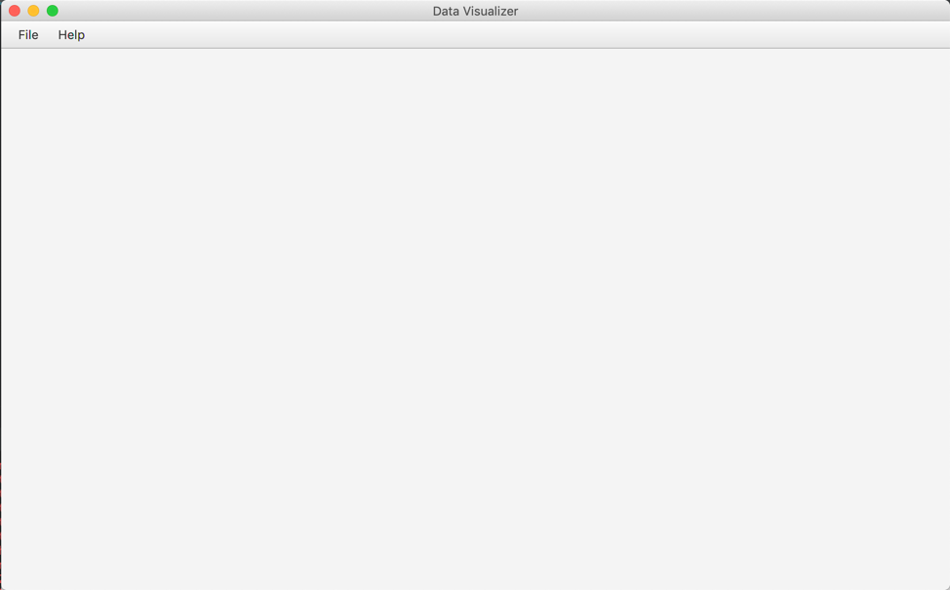

Figure 1

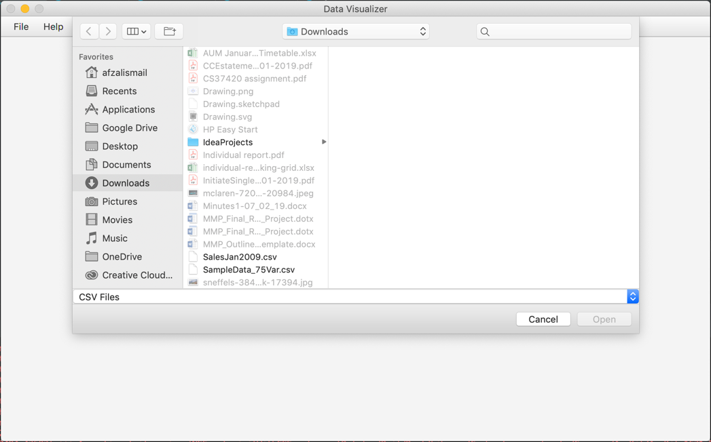

Figure 2

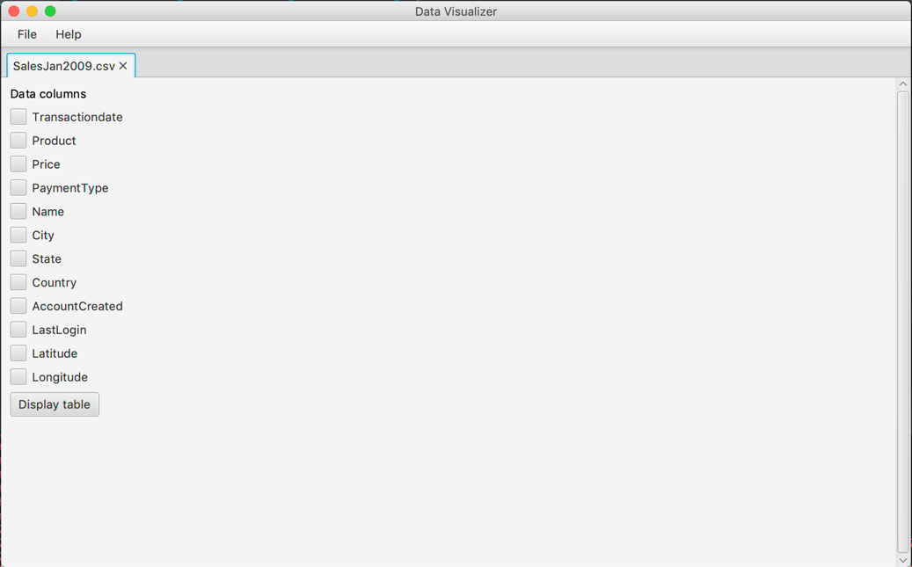

Figure 3

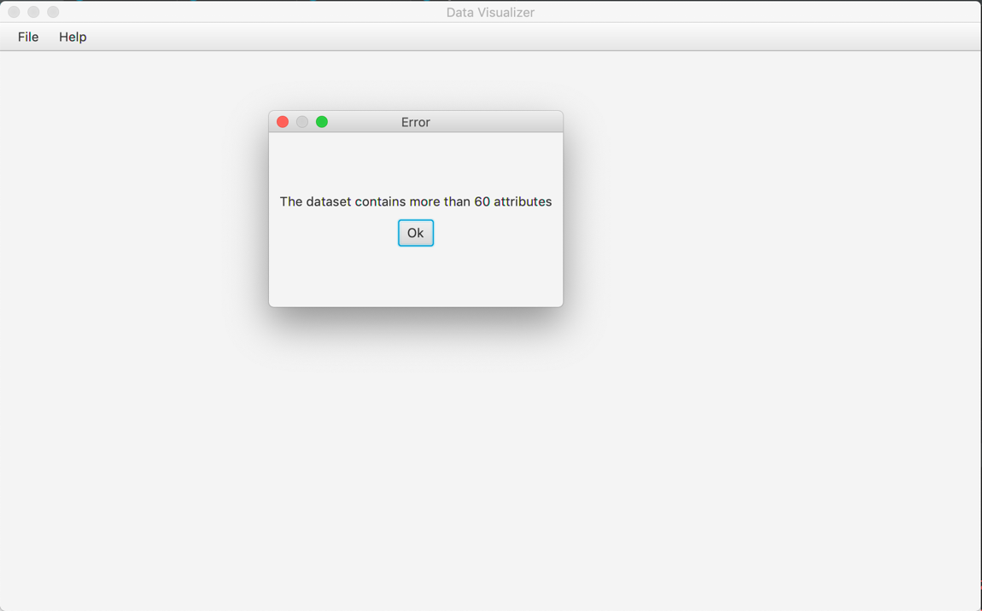

Figure 4

**Appendix B**



|  |  |  |
| --- | --- | --- |
| **Signature of Student:** |  | **Date: 22/02/19** |
| **Signature of Supervisor:** |  | **Date:** |